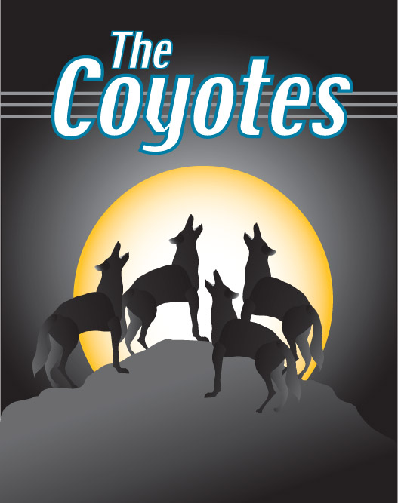
http://www.thecoyotes.ca

